**REQUIREMENT ANALYSIS PHASE**

|  |  |
| --- | --- |
| **Date** | **25-06-2025** |
| **Team Id** | **LTVIP2025TMID31548** |
| **Project Name** | **field service workorder optimization** |
| **College Name** | **Ideal Institute Of Technology** |

* **Customer Journey Map**

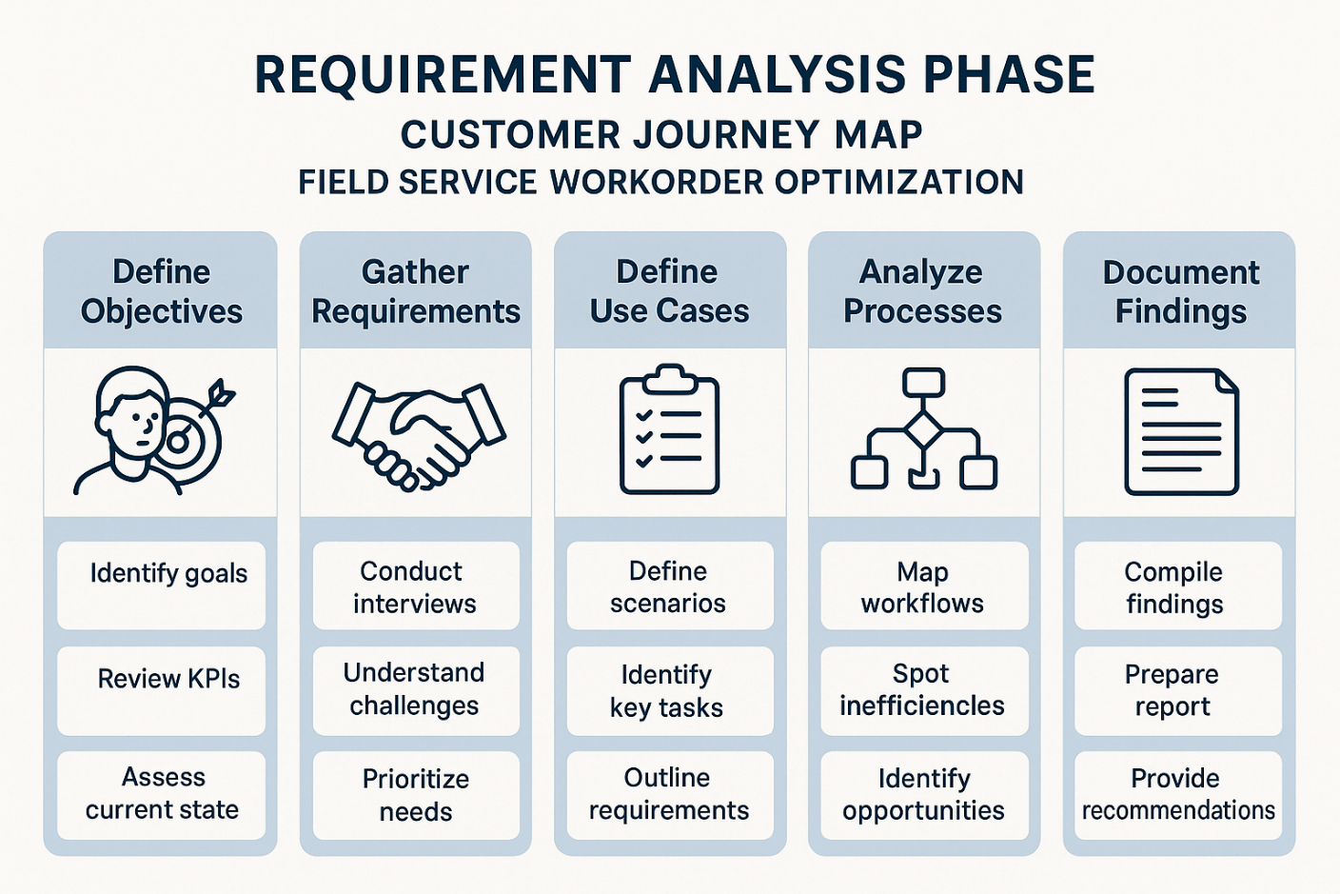

* **Solution Requirements**

**✅ Functional Requirements**

**1. Work Order Management**

* Create, update, assign, and close work orders.
* Support for different types: installation, maintenance, emergency repairs.
* Link work orders with accounts, assets, service contracts, etc.
* Define SLAs and track compliance.

**2. Scheduling & Dispatching**

* Automated scheduling using optimization algorithms.
* Manual drag-and-drop scheduling in dispatch console.
* Real-time technician availability view.
* Multi-day and recurring work orders.

**3. Route Optimization**

* GPS-based routing to minimize travel time.
* Consider constraints: traffic, distance, service windows.
* Real-time rerouting due to cancellations or delays.

**4. Technician Skill Matching**

* Match work order needs with technician skills, certifications, and availability.
* Consider location and equipment.

**5. Inventory & Parts Management**

* Check technician van stock and warehouse stock.
* Automatically associate parts used with work orders.
* Trigger replenishment requests.

**6. Mobile App / Field Technician Interface**

* Offline capability.
* Work order checklist, photo upload, digital signatures.
* Navigation assistance.
* Ability to update status, log time and materials.

**7. Customer Communication**

* Appointment confirmations, reminders via SMS/email.
* Real-time ETA tracking for customers.
* Feedback collection after service.

**8. Asset & Equipment Management**

* Maintain asset service history.
* Track warranties and contracts.
* Monitor IoT-connected devices for proactive service.

**9. Analytics & Reporting**

* SLA compliance, first-time fix rate (FTFR), travel time, technician utilization.
* Real-time dashboards for dispatchers and management.
* Historical data trends for predictive maintenance.

**🔒 Non-Functional Requirements**

**1. Performance**

* Real-time updates with low latency for mobile and dispatch systems.
* Scalable to support hundreds or thousands of technicians.

**2. Security**

* Role-based access control (RBAC).
* Data encryption in transit and at rest.
* Mobile device security & remote wipe capability.

**3. Scalability**

* Ability to support expanding technician teams, work order volume, and geographies.

**4. Integration**

* ERP/CRM integration (e.g., SAP, Salesforce, Oracle).
* Third-party GIS, IoT systems, and telematics.
* Payment gateways, eSignature platforms (DocuSign, Adobe Sign).

**5. Configurability & Extensibility**

* Business rule engine to support custom workflows.
* Custom fields, layouts, notifications.
* APIs and integration tools (e.g., MuleSoft, Zapier).

**6. Usability**

* Easy-to-use UI for dispatchers and technicians.
* Support for local languages (if multinational).
* Minimal training required.

**7. Reliability & Availability**

* High availability (99.9% uptime or more).
* Failover and disaster recovery strategy.

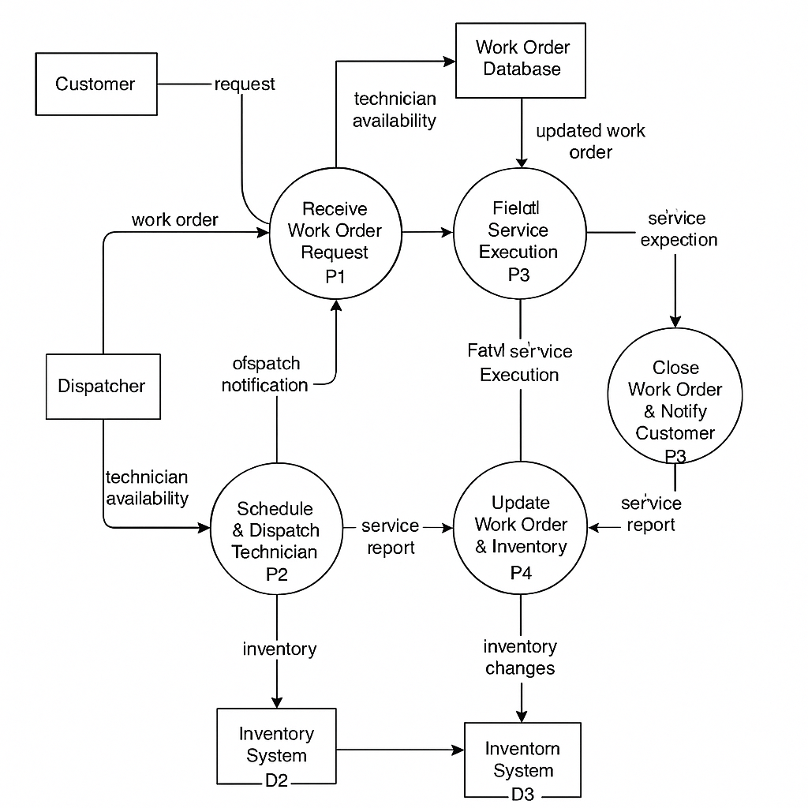 **Level 1 DFD – Full Workflow**

**Data Flow Diagram (DFD) - User Authentication Module**

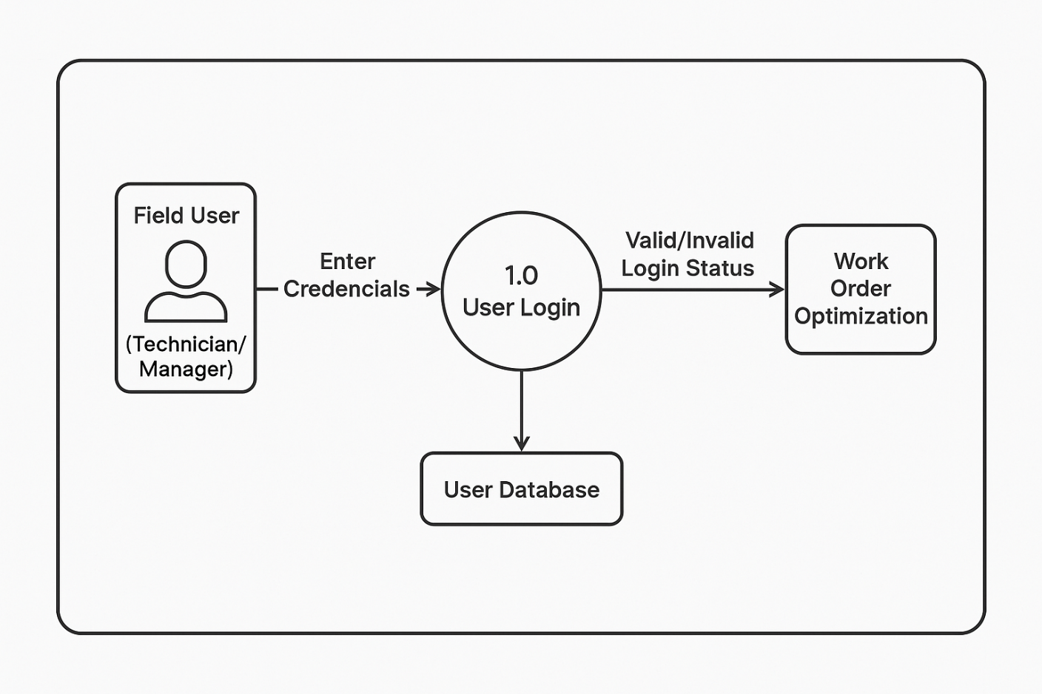

* **User Stories**

| **#** | **User Role** | **User Story** | **Benefit** |
| --- | --- | --- | --- |
| **1** | Dispatcher | As a dispatcher, I want the system to auto-schedule work orders based on availability and proximity | To reduce travel time and increase job completion |
| **2** | Dispatcher | As a dispatcher, I want to view real-time technician locations on a map | To assign jobs to the closest available technician |
| **3** | Field Technician | As a technician, I want to access and update work orders from a mobile app | To work efficiently in the field without office visits |
| **4** | Service Manager | As a manager, I want the system to prioritize work orders by SLA and customer value | To ensure critical jobs are completed on time |
| **5** | Dispatcher | As a dispatcher, I want automatic reassignment when a technician is unavailable | To prevent delays in service delivery |
| **6** | Service Manager | As a manager, I want to analyze completion times, delays, and performance | To identify improvement opportunities |
| **7** | Customer | As a customer, I want ETA notifications when a technician is en route | To be prepared for the service visit |
| **8** | Technician | As a technician, I want to check parts availability before traveling | To avoid incomplete jobs due to missing parts |
| **9** | Technician | As a technician, I want optimized routes for daily jobs | To reduce travel and increase productivity |
| **10** | Maintenance Scheduler | As a scheduler, I want to automate recurring work orders | To avoid manual creation and ensure timely maintenance |

* 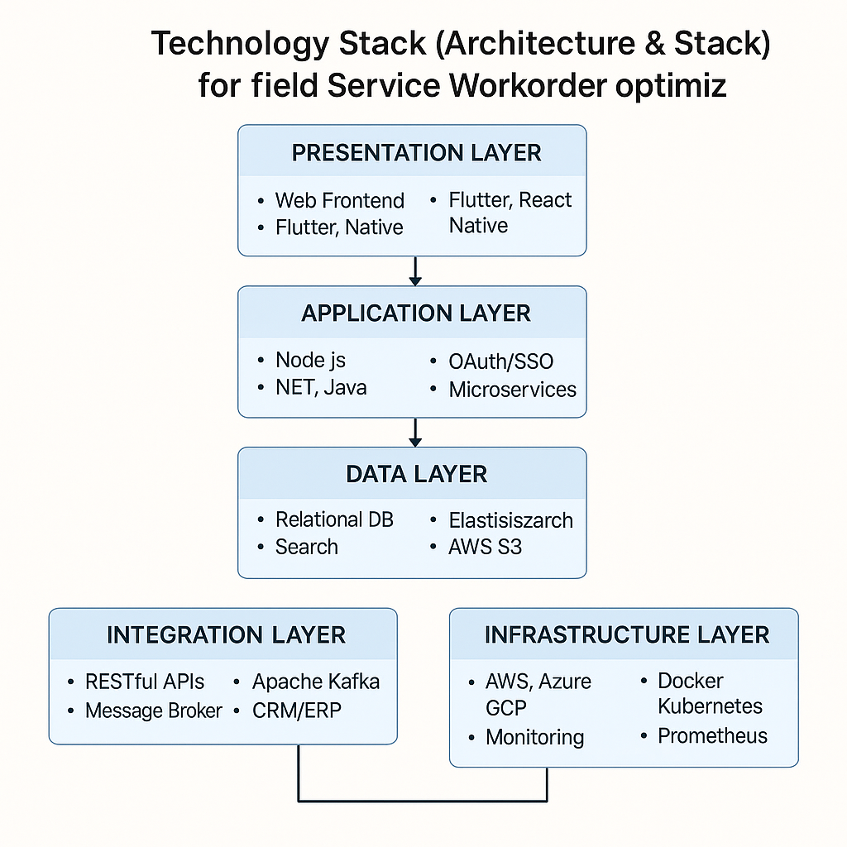**Technology Stack (Architecture & Stack)**

## Technology Stack Overview

| **Layer** | **Purpose** | **Technologies** |
| --- | --- | --- |
| **Presentation Layer** | User Interface for Web and Mobile | React.js, Angular, Vue.js, Flutter, React Native, Swift, Kotlin |
| **Application Layer** | Business Logic, Authentication | Node.js, Spring Boot, .NET Core, Django, OAuth 2.0, JWT, Microservices |
| **Data Layer** | Data Storage and Management | PostgreSQL, MySQL, MongoDB, Elasticsearch, AWS S3, Azure Blob Storage |
| **Integration Layer** | System Connectivity and API Management | REST/GraphQL APIs, Apache Kafka, RabbitMQ, Salesforce, SAP, Google Maps |
| **Infrastructure Layer** | Hosting, Scaling, CI/CD, Monitoring | AWS, Azure, GCP, Docker, Kubernetes, GitHub Actions, Jenkins, Prometheus |
| **Optional Add-ons** | Intelligence & Automation | AI/ML, IoT Sensors, RPA (UiPath, Automation Anywhere), Predictive Analytics |